Configuring the kitchen printer (for online ordering):
Scenario: The FC needs help configuring their kitchen printer.

- Log into the AX5 point-of-sale system with your PIN.
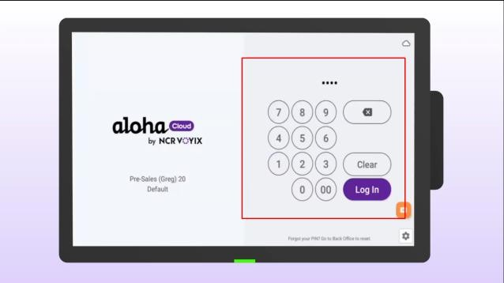
- Click the menu in the top left corner of the screen.
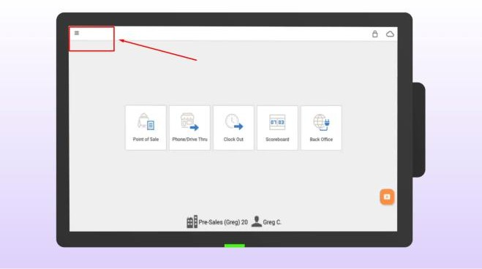
- Select SETTINGS.
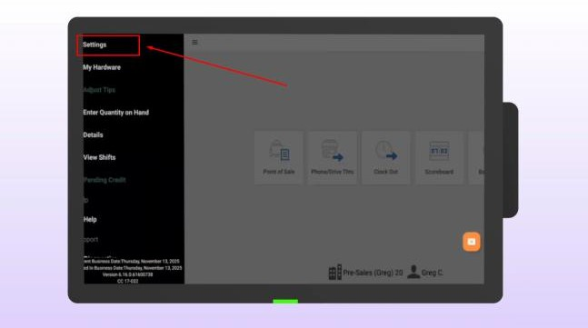

- Select KITCHEN PRINTERS.
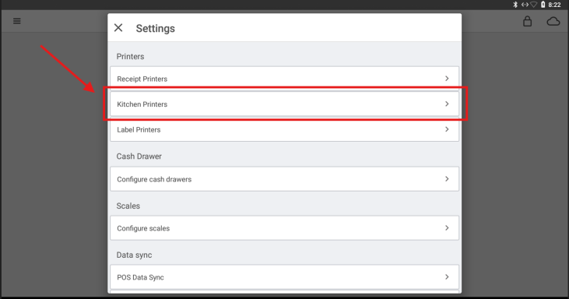

Tap ADD LOCAL PRINTER.
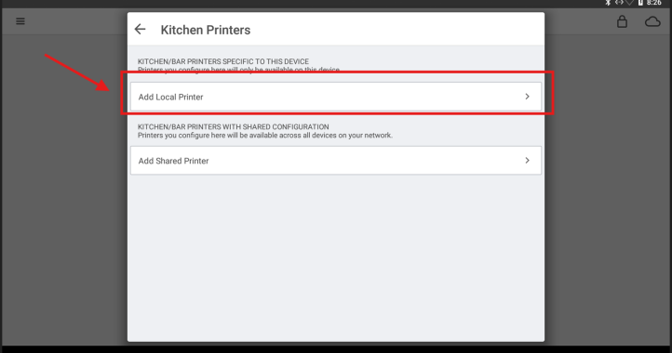
- Wait for the system to discover the printer, then tap the USB Printer option.
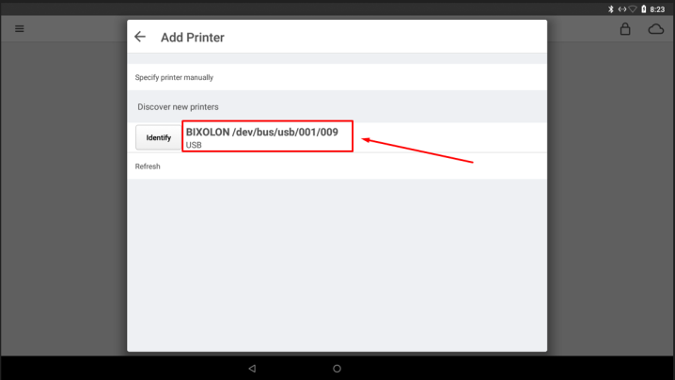

- Click "Online Printer" if this is for the Counter, or "Drive Thru Printer" if it’s for the drive-thru.
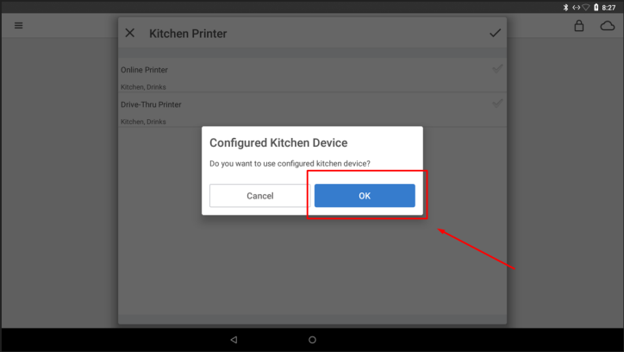
- Once you see the green check mark next to the kitchen printer that you configured, tap the check mark in the top right corner.
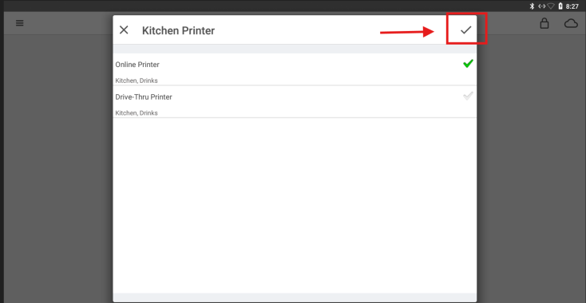

You can now read below ONLINE PRINTER: "Kitchen, Drinks". This means the system has been correctly assigned.
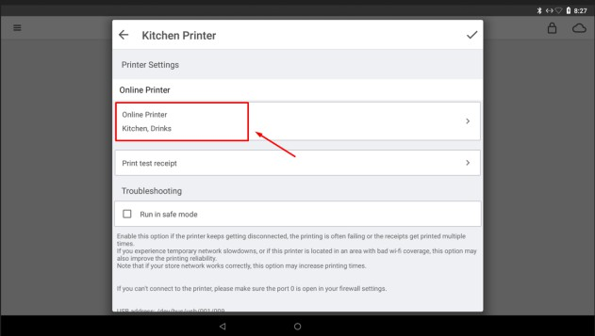

Tap the check mark to finish.
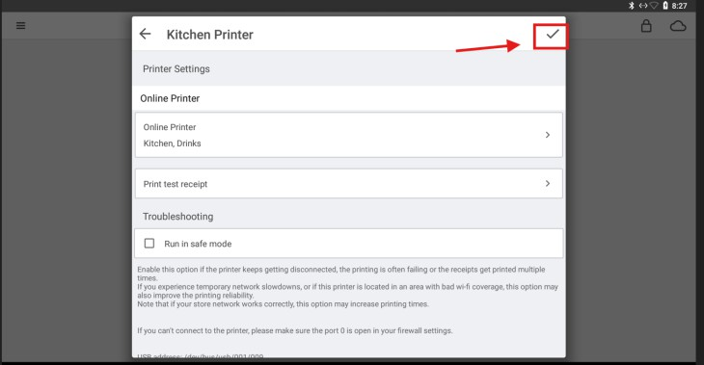

You should now see the newly installed printer under KITCHEN PRINTERS. You may now return to the main screen.
